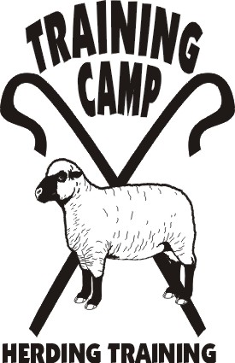

Presents
HERDING 101

Now that you have been bitten by the herding bug do you want to know and understand more about what you are doing and why?

This seminar will give you the opportunity to learn the language, and begin to understand the parts you, the dog, and the livestock play. You will find things that you can do at home to make herding training easier and you will find out about setting goals for you and your dog.

March 14, 2015

9 am to 3 pm
$75

This seminar will be held in my home. Limit 10 people. Lunch and seminar materials provided.

Address: 4047 Sheridan Ave. So.
Minneapolis, MN 55410
joannayund@gmail.com
www.trainingcampinc.com

